CMP208 – Game Programming and System Architectures

Ollie Hall - 1700066

Grapnel Garry

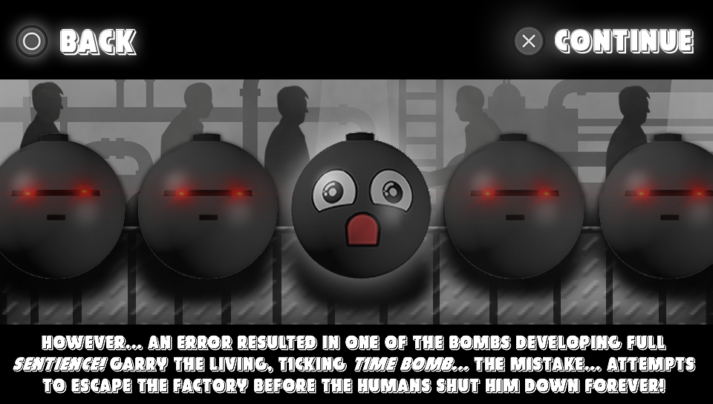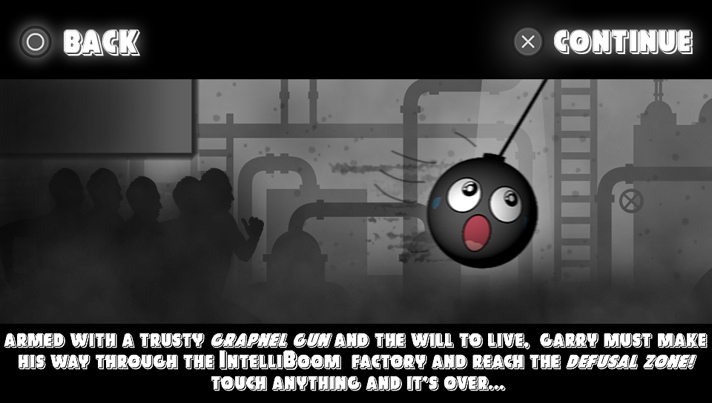

Introduction

The application is a physics-based, 2.5D platformer designed with the intention of providing the user (or player) with a challenge that requires timing and skill to overcome. The game revolves around the mechanic of the character controlled by the player having to swing from a rope that can be attached to any surface – The player will lose if the character manages to touch anything. This allows the player to play within a physics-based playground that is both fun and exhilarating yet manages to provide a meaningful challenge that provides the player with a sense of satisfying accomplishment once overcome.

The game also includes other mechanics: Pressing X causes the player to launch into the air from swinging, allowing them to gain verticality when needed. Slow-motion, whilst a common mechanic in many games, was deemed important for this game so that the player can have enough time to aim at surfaces and guess their swing trajectory – this is activated by holding the left bumper on the PlayStation Vita. Ray casting was also implemented into the game and is controlled with the right joystick. This is very important as it allows the player to find the nearest surface to grapple to in the direction that they are aiming, and it represents where the rope will be so that the player can visualise how their swing will perform in the physics of the game. Using the left joystick allows the player to extend or retract the length of the rope connecting the character with the surface that it is attached to – this gives the player much more control over where the character goes, and when used properly it is highly effective and satisfying to use.

When the player reaches the end of the level (called the “defusal zone” in the game), the game is won, and they are returned to the menu along with a record of the time it took for them to complete the level. If the new time is faster than the fastest time that was previously recorded, it becomes the new high score.

The inspiration for the design and implementation of the swinging mechanic mainly comes from the 2018 PlayStation 4 game ‘Marvel’s Spider-Man’. The feeling of euphoria that the player feels after executing a good swing was a desirable experience that this application intends on replicating. Other inspirations for the application design include that of ‘Cuphead’ (2017) for the olden-style visuals and character design stemming from 1930s cartoons, or Miniclip’s ‘Doctor Carter and The Cave of Despair’ – a flash game where the player must swing from the ceiling of a cave towards the exit whilst being pursued by a tidal wave of lava.

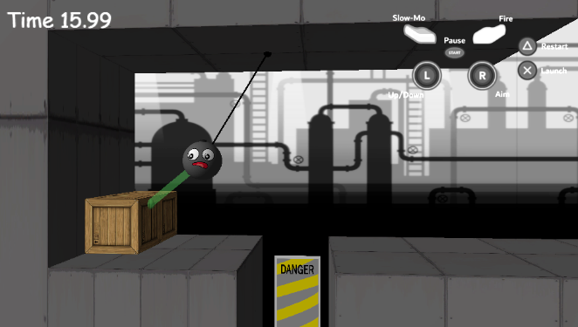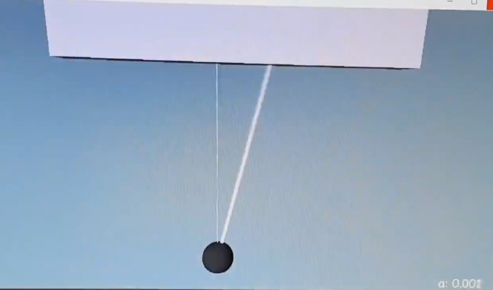

Creating the rope mechanic.

It was very important for this feature to be implemented and refined before continuing development of the game

A fully implemented raycast system, multiple surfaces and an animated player model.

Application Design